The Skies have opened up-finally

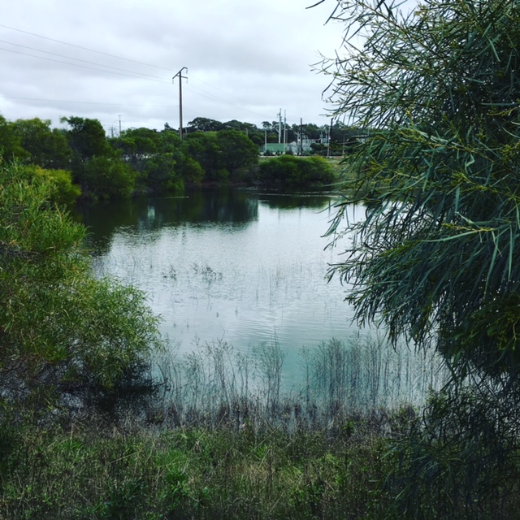 |  | - Winter 2017
Georgiadis estates Block 3 Shiraz |  | In This Issue

Coming off of our best ever year, quality wise, due to a very wet and cold 2016 winter, we were skeptical as to whether winter rains would fall and replenish the soil profiles. We turned on the water to begin irrigating and within days the rain came and has consistently fallen. Excellent news for grain farmers and grape growers alike. With only a few warm days just experienced, you’ll notice almond trees already beginning to bloom. It seems impossible with the very cold winter days and nights we’ve had this winter that buds could begin pushing in the next 3 weeks or so. We will have to wait and see what this current weather pattern brings before further predictions are made. But every grape grower is jumping for joy with the continued winter rains that will allow the moisture to go deep and ensure that the vines have the moisture needed during the early growth period.
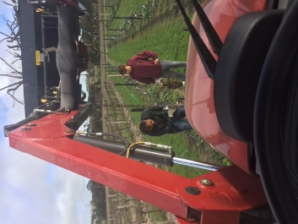

We received a fantastic review by Dan Trauki, winewriter WBM Magazine
2014 'THE MELEE' GRENACHE/NERO d'AVOLA/SHIRAZ/MALBEC- Lashings of light bright purple colour, vibrant raspberry aromas with a smidge of spice. Oodles of lively juicy berry flavours with some dusty oak and a long lingering classy finish. BLOODY GORGEOUS.
P.S. By the way the 2016 tank sample (Sangiovese/Shiraz/Malbec) was even bigger and brighter-it will be an absolute corker when it is released and will age for eons !!

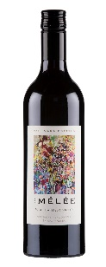
2014 Melee

NEW RELEASES
We’ve just bottled our 2016 Melee (Sangiovese, Shiraz, Malbec) and as Dan says it’s ‘a corker’. Try it for yourself! $21

We have bottled our first ever estate grown 2015 DeNero (Nero D’Avola)
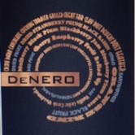
We are very excited about the new addition to our family.
Expressing fine leathery tannins with powerful seductive aromas of black cherries and plums. Deep in colour, loaded with fruit, reminiscent of blackberries, cranberries and goji berries, a savoury wine with natural acidity, a little spice and a captivating coffee character. Truly scrumptious! $22

